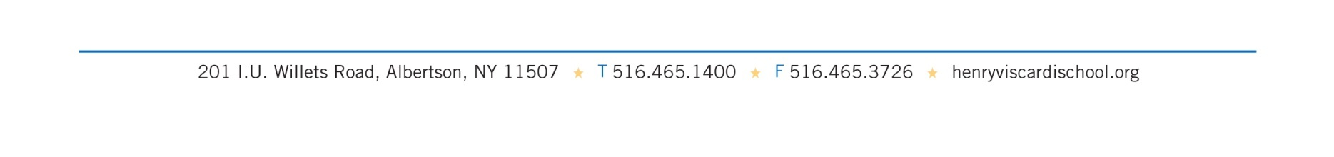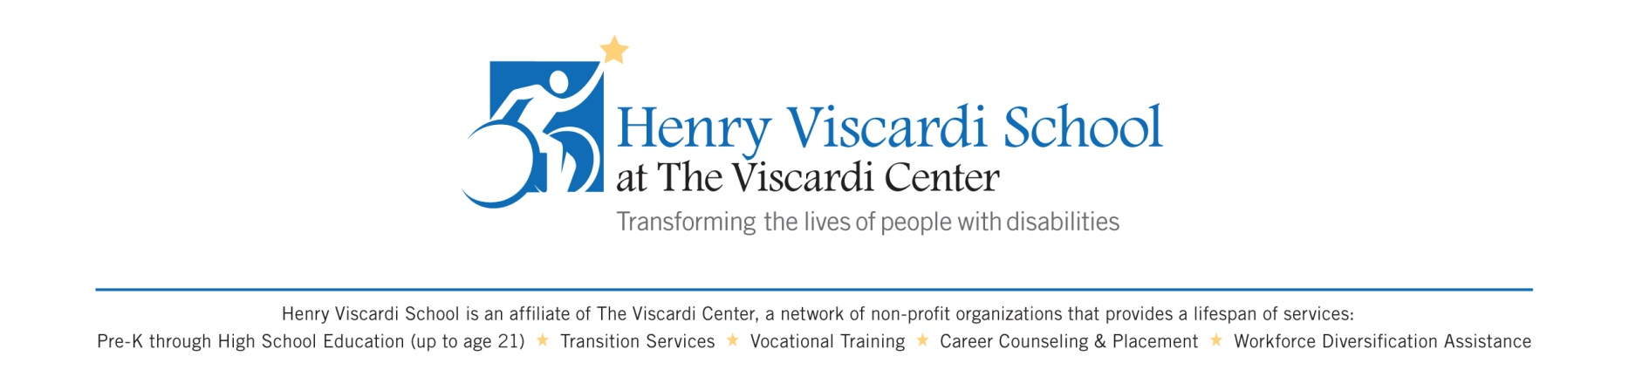

October 20, 2020

Dear Henry Viscardi School Community:

Today, October 20, 2020, the Henry Viscardi School was notified that a staff member has tested positive for COVID-19. The staff member was in school yesterday.

In accordance with Henry Viscardi School’s reopening plan, the Nassau County Department of Health (DOH) has been notified, and the school is assisting in its contact tracing efforts. The DOH will inform those who are identified as being a close contact and will issue quarantine orders as necessary.

Out of an abundance of caution, and to mitigate any exposure in the building, the Henry Viscardi School has decided to close beginning Wednesday, October 21 through Friday, October 23. During this extended school closure, all students and staff will follow a fully remote schedule until in-person learning resumes on Monday, October 26.

The Department of Health (DOH) will notify individuals who were in close contact with the positive individual which is defined as someone who was within 6 feet of an infected person for at least 10 minutes, 48 hours before illness or positive test results. Any staff member and/or student who is directed to quarantine will return to HVS only when released to do so by the DOH. If you do not receive communication directly from DOH or HVS it means you did not have close contact with the positive individual.

We understand this announcement represents a disruption to all of our daily lives and schedules. Please be assured that we will be transparent about any COVID-19 cases in our school and we will keep you informed if more information needs to be communicated.

Sincerely,

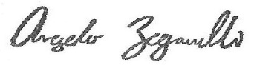

Angelo Zegarelli

Head of School