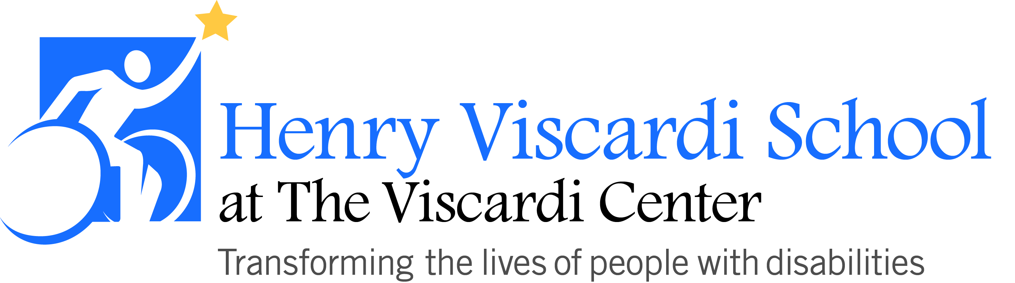

FOOD POLICY

In order to provide a comfortable, safe, and stress-free school day for all, the following procedures are followed:
- Food Items (i.e. cupcakes, pizza, donuts, juice boxes) are not to be sent to school for consumption by all students. Students are only permitted to eat the food sent in from their own homes. If food items are sent to school for an entire class, they will be returned.

- As a substitution for food items to be used during a celebration, party favor items (necklaces, hats, books, crayons, etc.) can be sent in to school for all students.

- During classroom activities, school-wide celebrations, field trips, or other events where food will be served to students, parents/caregivers will be notified in advance of what will be served and then will have the opportunity to decline the food items for their child. As a substitution, parents/caregivers may send food for their child.

