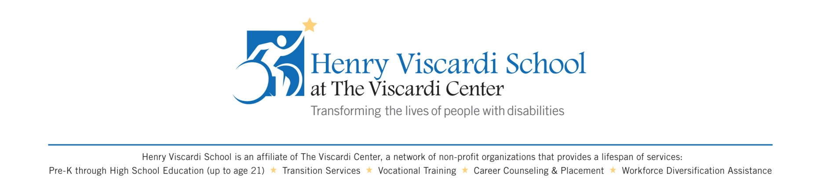

September 1, 2022

To Whom It May Concern:

Henry Viscardi School’s hours are 8:30 AM – 3:15 PM. The total number of instructional hours for Kindergarten through 12th Grade is six hours.

Sincerely yours,

Angelo Zegarelli, Head of School